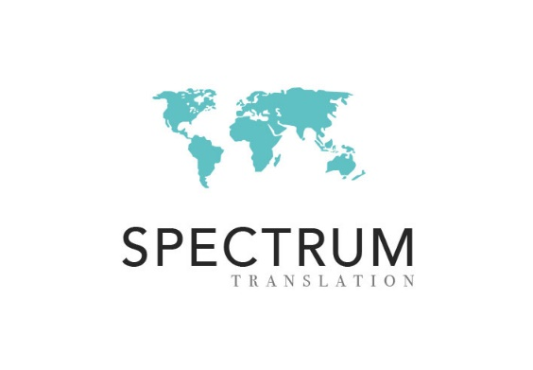

Linguistic Validation Project
Irish (Gaelic)/Ireland

Language: Irish (Gaelic)
Country or area: Ireland
Condition: cancer (breast, gastrointestinal, genitourinary, gynaecologic, head and neck, lymphoma, leukaemia, melanoma, myeloma, prostate, thoracic)
Number of participants: 5 adults (18+)
Number of words: 2214
Compensation: $150/€135 (approx.)
Interviews: telephone
Expected start date: December 2024

OUR PRIVACY POLICY:

Please provide the information below if you would like us to contact you by email or telephone with information about this linguistic validation project. We will process your data in accordance with our Privacy Policy https://www.spectrumtranslation.com/privacy-policy/.

E-MAIL: By sending your information by e-mail, you have explicitly consented to receive communications from us regarding the linguistic validation projects.

WEBSITE: By clicking ‘submit’ to send your information through the form on the linguistic validation page (https://www.spectrumtranslation.com/linguistic-validation/), you have explicitly consented to receive communications from us regarding the linguistic validation projects.

You may withdraw this consent at any time by emailing us at info@spectrumtranslation.com.

The Linguistic Validation Projects

Linguistic validation is used to assess the quality of texts intended for a particular country, region or area of the world. The text is normally a translation from English, and now native speakers of the target group are needed to evaluate the quality during an interview.

Requirements

The details of this project are given in the box above. All who participate must have the medical condition noted, and following completion of the interview, each participant will receive the amount noted or its equivalent in the local currency.

Telephone Interviews:

If the translation or localized text is to be evaluated by telephone, the interviewer will call the person to schedule a time for the interview. There should be no telephone costs involved for the participant, as the interviewer will be calling the participant.

In-person Interviews:

Most of the linguistic validation projects involve in-person interviews. The interviewer will contact the participant by phone or e-mail to schedule a time for the interview. Together with the interviewer, each participant can decide on the most suitable location for the interview. This could be a café, library, hotel lobby or the person’s own home.

Payment:

Participants will receive their payment for participation within good time, usually within one week of participating in an interview. We offer two forms of electronic transfer: bank transfer (with IBAN code and BIC/SWIFT code) or PayPal.

For those who have no bank or PayPal account, cash received from the interviewer at the end of the interview is possible for in-person interviews only. Where cheques are used, the interviewer may be able to offer participants payment by cheque.

FAQs:

Do I need to know English or another language to participate?
No. The entire interview will be in the language of the translation. (English will only be used for English-speaking countries.)

Do I need any special medical knowledge to participate?
No. No medical knowledge apart from the participant’s own experience with the medical condition concerned is required to participate.

What types of texts are evaluated?
The texts are mostly medical questionnaires for use in clinical trials.

How will I evaluate the quality of the translation?
The interviews mostly involve paraphrasing the text, that is, putting it into your own words. You may note anything which you think is not standard usage or would be difficult for a native speaker of your language in your country or location to understand. You may also add anything else you would like about the quality of the translation.

Do I also have to answer the questionnaire or only evaluate the quality of the translation?
The focus of the interview is to assess the quality of the translation or localized text. For the most part, participants will only be evaluating the language of the questionnaire. For many projects, however, the participant is also asked to respond to the questions in the survey. The responses are only recorded to see whether the text can be easily understood or not.

How is my input recorded?
The interviewer will note down anything you say about the quality of the text. Only rarely is the interview recorded, and if this is the case with your project, you will be informed in advance of this.

How will my input be used?
The results then appear anonymously (so participants are listed as Subject 1, Subject 2, and so on) in a report given to the translators, who then revise the text based on the participants’ responses.

May I take part in future linguistic validation projects?
Yes. At the end of the interview, if you would like to keep your personal data on file to participate in future linguistic validation projects, just let the interviewer know. (Participants may take part in up to three projects per year.) Anyone who would like to stay on file is welcome to let us know this (in writing) and will be contacted again as new linguistic validation projects for their language/country combination appear.

Without this consent, your information will be deleted following completion of the project.

Will my personal data be used for any other purpose?
No. We keep contact and other information solely for the purpose of contacting people about upcoming linguistic validation projects. Your information will not be shared with any third parties (our client receives no names or contact information), and as noted in our privacy policy, you may update it or withdraw your consent for it to be stored at any time by sending an e-mail to this effect to info@spectrumtranslation.com.

How will I be paid?
As noted above, we make all effort to pay within one week of completion of the project. For this we need accurate payment information, that is, correct bank or PayPal account information.

Cash is only available for those participating in an in-person interview.

DATA REQUIRED OF PARTICIPANTS

Those who are interested in taking part in the linguistic validation projects should provide the following information. The information is used for only one purpose: assessing the translation through evaluation in a one-on-one interview.

In the interest of data minimization, please only provide information which is absolutely necessary for the interviewer to contact you and for us to confirm your age, years of education and medical condition (if any).

If you would like to take part in this linguistic validation project, please provide this information:

First name LAST NAME:
Do you have cancer (breast, gastrointestinal, genitourinary, gynaecologic, head and neck, lymphoma, leukaemia, melanoma, myeloma, prostate, thoracic)?
 Yes. Please give a brief description (year of diagnosis, etc.):
 No.
Date of birth:
Gender:
County of residence in Ireland:
E-mail address:
Telephone number:
Mobile number:
Best time to be contacted:
Years of academic education (starting from Grade 1):
(Note: vocational education or training is not counted as academic education. Please only provide the number of years, e.g. 8, 12, etc.)
Method of payment:
(Note: payment information may be provided after the interview and is not required to apply for the linguistic validation projects.)
 Bank transfer:
Name:
BIC/SWIFT code:
IBAN code:
Address of bank:
 PayPal:
 Cash (in-person interviews only):

Any information provided for the purposes of the linguistic validation projects will be used for that purpose alone in accordance with the GDPR regulations on ‘data protection by design’. If you do not give consent to us storing your information after the interview, it will be deleted. Without this consent we can no longer communicate with you for the projects.

Thank you for your interest in the linguistic validation projects.

Best regards,

Brian Granger
Project Manager
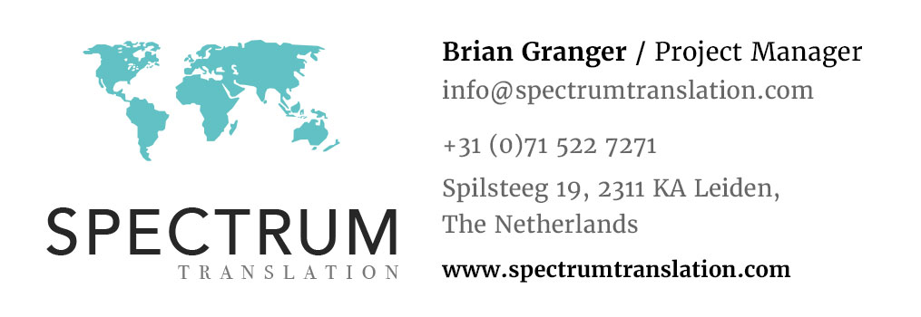

ANNEX:
YOUR PRIVACY IS IMPORTANT

OPTING OUT

How do I opt out?

As noted above, just send a message to info@spectrumtranslation.com. If you do not use e-mail, you may also let the interviewer know by phone, who will then pass this information on to us. You may also send this request in writing to:

Spectrum Translation
Spilsteeg 19
2311 KA Leiden
The Netherlands

Upon receipt of your request to opt out, your information will be deleted immediately. (For more information, see our Privacy Policy at https://www.spectrumtranslation.com/privacy-policy/, the right to erasure/to be forgotten.)

UPDATING DATA

How do I update my information?

If any of your contact or other information has changed (e.g. there has been a change of name, you have moved house, got a new telephone number, etc.), just a send a message to info@spectrumtranslation.com. If you do not use e-mail, you may also let the interviewer know by phone, who will then pass this information on to us. You may also send this request in writing to:

Spectrum Translation
Spilsteeg 19
2311 KA Leiden
The Netherlands

Upon receipt of the new data, your information will be updated immediately.

YOUR RIGHTS

We take your privacy seriously and have implemented all measures available to secure the data you provide us. As noted in our Privacy Policy, you have these rights with regard to your data:

Under data protection laws you have rights in relation to your personal data that include the right to request access, correction, erasure, restriction, transfer, to object to processing, to portability of data and (where the lawful ground of processing is consent) to withdraw consent.

(For more information, see our Privacy Policy at https://www.spectrumtranslation.com/privacy-policy/.)

DATA PROTECTION BY DESIGN

We follow the Privacy (or Data Protection) by Design concept and have implemented comprehensive data protection controls based on the following principles:
- Data minimization (we only collect data that is absolutely necessary to conduct our business).
- Access restriction (we only allow data access to those who need to know to conduct our business).
https://ico.org.uk/for-organisations/guide-to-the-general-data-protection-regulation-gdpr/accountability-and-governance/data-protection-by-design-and-default/

‘Data protection by design is about considering data protection and privacy issues upfront in everything you do. It can help you ensure that you comply with the GDPR’s fundamental principles and requirements, and forms part of the focus on accountability.’

Data protection is an essential component of the linguistic validation projects. Only Spectrum Translation (including the interviewer) will have access to your contact information, and it is only ever used for the purposes of the linguistic validation projects.

